ELEC-240 Lab1
Introduction to the ST-Microelectronics STM32F429 Nucleo-144 Development Board *
Stuart MacVeigh, Paul Davey

1 Introduction
The purpose of this lab is to introduce you to the ST-Microelectronics Cortex-M4 processor using the ARM Keil MDK toolkit featuring the µVision IDE. The hardware you will be using in this lab session is the STM32F429 Nucleo-144 which incorporates the STM32F429 micro-controller. It also has an on-board ST-Link V2 debugger with Serial Wire Viewer (SWV) which we will be using to program and debug the board.
Please see Table 2 for access to the relevant support documentation for the Nucleo-144 development boards.
- By the end of this lab exercise you should be able to
- Install and run the Keil µVision IDE on a Windows PC and install the necessary packs, legacy support drivers and hardware (USB) drivers.
- Create a µVision project, edit and compile code and download it to the micro-controller.
- Open and manage µVision project ﬁles.
- Use the debug function to monitor variables, pause and single step through code execution.
If you get stuck with any part of the exercise, ASK for help! otherwise you’ll fall behind.

2 Keil Software Installation
Keil projects contain multiple ﬁles.
- First rule of Keil project ﬁle management
- Keep all project ﬁles inside their folder, do NOT separate them!
When copying or moving Keil projects make absolutely sure you copy/move the entire folder so that all the associated ﬁles are kept together with the project ﬁle. Keep this in mind for later tasks.
- If you already have Keil µVision installed on your PC then skip to Section 3.
- You can acquire the installer for Keil v5.21 from the lab network storage at
\\10.208.130.20\StudentShare\elec230\Installer
Copy the MDK521a.exe ﬁle to your computer and run it, do not try to execute it directly from the network drive.
2. Install the USB drivers
Assuming you’ve installed to the default directory go to
C:\Keil\_v5\ARM\STLink\USBDriver
and run the dpinst amd64.exe if you’re using a 64bit OS or dpinst x86.exe if you’re running a 32bit OS.

3 Opening a Keil Project
The .uvprojx extension is the project ﬁle which will launch Keil and open the project.

3.1 Installing Legacy Support
If you’re working with a new install of Keil you may see this message on start (if not then skip to Section 4).
Figure 1: Legacy Support Drivers Missing Message
If this is the case then click the Install Legacy Support (bottom button). This will take you to here where you will see the following screen (Figure 2).
Figure 2: ST Legacy Support Page
Click Download Legacy support for Cortex-M devices (left-hand button). This will download the MDKCM5xx.exe ﬁle. Run this ﬁle and follow the instructions to install the legacy drivers.
Note: On the screen which asks you to backup old conﬁgurations, un-tick the box as this is not necessary.

3.2 Installing Packs
In Keil, click on the icon on the top bar, this window will open
Figure 3: Keil Pack Installer Window
If the list does not appear as shown in the left-hand pane of Figure 3 then click the refresh icon in the top-left corner. Progress of any operation is shown in the bottom-right corner as shown in Figure 4.
Figure 4: Pack Installer Progress Indicator
Once refreshed the left-hand pane should show a list of available devices, navigate to the correct device as shown in Figure 3 left-hand pane.
In the right-hand pane, for any devices that aren’t showing as up to date, click Update/Install to bring them up to date (ignore Oﬄine or Depreciated attributes).
Again the progress of the install is indicated in the bottom-right corner as shown in Figure 4.
Once complete they should all display Up To Date as shown in Figure 5.
Figure 5: Pack Installer Window showing all attributes Up To Date
Once complete close the pack installer window. If Keil has been running while the packs were being installed it will now display a pack reload request, shown in Figure 6, click Yes and you should then be presented with the screen shown in Figure 7.
Figure 6: Reload Packs Message
Figure 7: Keil Main Screen
The pane down the left-hand side shows all the ﬁles associated with the project. The main section in the centre shows the code.

4 Task 1: LED Flash
Make sure the board is plugged in to the computer and that the USB drivers are all installed (refer to Section 2).
Download the example project from the DLE (under “Lab 1” section) to a local directory on your PC such as the Desktop and extract the ﬁles from the ZIP folder.
Inside the extracted folder ‘STM32F429 Nucleo-144 test code’ you will ﬁnd a variety of ﬁles.
Open the ﬁle labelled test.uvprojx. See Section 3 for details if necessary.
- Click the button to open the settings window (shown in Figure 8a).
Figure 8a Settings Window
- Under the Debug tab select the ST-Link debugger from the list (Figure 8b) and then click Settings.
Figure 8b Debugger Selection Window
- In the Debug Adaptor section set the Port to SW communications protocol (Figure 8c circled in Blue).
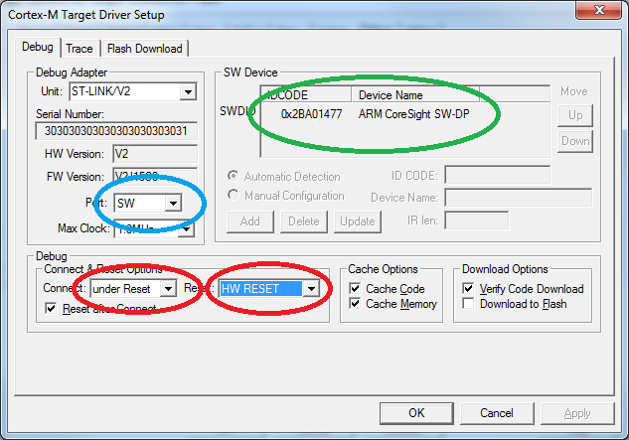
Figure 8c Debugger Settings Window
- Set the Connect & Reset Options so they match that shown in Figure 8c circled in Red.
- If this is done correctly the board ID should be displayed in the SW Device section as shown in Figure 8c circled in Green.
- Under the Flash Download Tab ensure that the Reset and Run box is ticked (shown in Fig 8d circled in Red.
Figure 8d Flash Download Settings Window

4.1 Compiling the Code
Click the Build button or press F7 on the keyboard to compile the code.
The compile output is shown in the bottom pane.
If all was successful it should end showing 0 Errors and 0 Warnings.
Warnings are displayed when undesirable commands are detected such as unused variables, mathematical errors etc.
Errors are displayed when illegal commands are detected. Most common causes of illegal commands are typographical errors when the code is being written. Misspelling a variable or function name will cause the compiler to complain that an undeﬁned function is being called or an undeﬁned variable is being used. Also forgetting to close a bracket at the end of a statement or function will produce an Error. In any event if Warnings or Errors have been detected you can scroll back up the output window to see what the cause of each was and double-clicking on it will take you to the oﬀending line in the code.

4.2 Downloading the Code
Click the Load button or press F8 on the keyboard to download the code to the board. The code can only be downloaded to the board if the compile was successful (no Errors).

4.3 Editing the Code
Deﬁne a variable labelled value as shown below
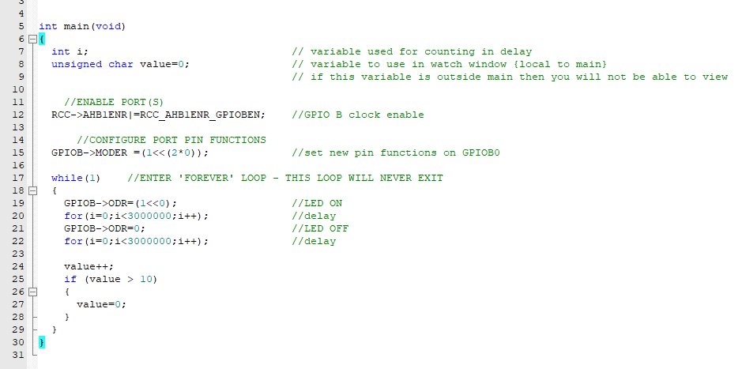
Figure 9 Watch a Variable
In Figure 9 the variable is deﬁned as a char which is short for ‘Character’ and is 8bits wide. Other available word lengths are ‘short’ which is 16bits wide and ‘long’ which is 32bits wide. The ARM micro-controller series have a 32bit wide bus architecture meaning that the default ‘int’ length is 32bit same as a ‘long’. Table 1 shows the full range of available word lengths and the values they can hold.
Word type | length (bits) | Min value | Max value
unsigned char | 8 | 0 | 255
signed char | 8 | -128 | 127
unsigned short | 16 | 0 | 65,535
signed short | 16 | -32,768 | 32,767
unsigned long/int | 32 | 0 | 4,294,967,295
signed long/int | 32 | -2,147,483,648 | 2,147,483,647
unsigned long long | 64 | 0 | 18,446,744,073,709,551,615
signed long long | 64 | -9,223,372,036,854,775,808 | 9,223,372,036,854,775,807
Table 1: Integer Word Lengths and the Values they can hold

4.4 Debugging
Compile and download the code to the board. Click to enter/exit debug mode. The debug screen is shown in Figure 10.
Click button to run the code.
Click button to pause the code.
Click button to reset the code.
Figure 10: Debug Mode Screen
- The contents of local variables can be monitored in the Call Stack + Locals window (Figure 10 circled in Red).
- The contents of global variables can be monitored in the Watch windows. To add a global variable to the Watch window, right-click and add as shown in Figure 11.
- Details on Local vs Global variables are given in Section 6.
Figure 11: Adding Global Variables to the Watch Windows

4.5 Break Points
Clicking on the side pane next to a line of code will create a break point. This will pause code execution when this line of code is reached. Clicking again will remove the break point.
See Figure 12. To remove all break points click button.
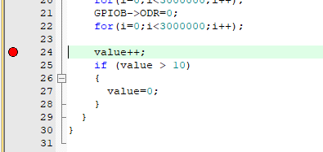
Figure 12: Setting a Break Point in Debug Mode
- Use the Step buttons 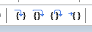to step through the code line by line to see value change

5 Task 2: Creating a Keil µVision Project
- In Keil go to Project -> New µVision Project
2. Create a new folder for this project to be stored into. (ELEC240Lab1)
3. Select the micro-controller version (STM32F429ZIT)
4. Include the relevant support ﬁles. Select CMSIS->CORE and Device -> Startup
5. Add a new source ﬁle to the project
6. Select the ﬁle type as .c and give it a name as shown (main is a good choice).
This ﬁle is where the code will be written/edited and compiled as covered in Section 4.
7. If a source ﬁle already exists simply right click the ‘Source Group 1’ folder, select ‘Add Existing Files to Source Group 1’ and import the necessary ﬁles.

6 Local Vs Global Variables
When a variable is deﬁned within a function that variable becomes a local variable.
When the program counter enters the function containing this variable it is allocated a slot in a temporary block of memory called the stack.
This variable is deleted when the program counter leaves the function. Because of this the contents of the local variable can only be monitored when the program counter is paused inside the function.
When a variable is deﬁned outside of a function or in a header ﬁle it becomes a global variable and is visible and usable to any functions below it in the page.
A global variable is allocated a static address in SRAM when the code is compiled and always maintains its value except for when the MCU is reset or powered oﬀ.

7 Support Documentation
The document names are hyperlinks, please click on them to access the documents and familiarise yourself with the information in the bullet points. You will need this for future reference.
UM1974 User manual
- Pin identiﬁcation and the supported special functions
- Circuit schematics
- Jumper and component identiﬁcation
- Header pinouts
RM0090 Reference manual
- MCU memory and peripherals architecture
- Peripheral control registers, addresses and bit-ﬁelds

